Feature Image: Upgrade your look with 2025's top diamond gold styles.

Title: Top Diamond Gold Necklace Styles for Men in 2025
Focus Keyword: diamond necklace for men
Secondary Keyword:
mens necklaces
Diamond gold necklace mens
black diamond necklace for men

Internal link
mens diamond necklace: https://crystaljewelersnc.com/product-category/mens-necklace/
Best jewelry store in Greensboro: https://crystaljewelersnc.com/

Word count: 1000
Meta Description:
Crystal Jewelers offers a premium gold diamond necklace for men. Find classic chains, black diamonds, layered styles and bold statement pieces in Greensboro.

Top Diamond Gold Necklace Styles for Men in 2025

Are you a man trying to find the right jewelry that captures the classic style, yet at the same time has some flair of the current trend? Look no further! The year 2025 has a lot of astonishing changes in jewelry, especially the diamond necklace for men. These trends have been observed at Crystal Jewelers to ensure you get the best diamond gold necklace styles for men. Well, if you are looking for a diamond necklace for a man or you simply want to know about men’s necklaces, then you are in the right guide. Here is a chance to take a closer look at some of the astonishing styles that can be seen.

Classic Elegance: The Ageless Diamond Gold Necklace
The first choice is the basic diamond gold necklace. It should not be surprising that there is something luxurious in a black smooth chain made of gold studded with diamonds. This timeless necklace is perfect from almost every angle, because beauty is not conclusive from one angle, as it is square. They are suitable for a formal occasion, you can wear them on your special dinner date, which you have been looking forward to all week.

The settings of diamonds in this Gold necklace provide it a contemporary touch. You can even personalize this necklace by modifying the settings of the diamonds, making them more artistic. These necklaces are not only a symbol of elegance but also a sign of a wise investment. Apart from personalization, this necklace also holds special value because gold and diamonds only appreciate in value, and this is definitely an investment that will not cease to grow.

The Edgy Choice: Black Diamond Necklace for Men
What can be equally perfect for a man is a black diamond necklace, which sets him apart from the other men who wear normal jewelry. These are stylish pieces of jewelry which have a distinct appearance that would surely turn the head of onlookers. Black diamonds are different from ordinary diamonds due to their smoother and mysterious look. It is important to suggest that they are a modern version of the more traditional ones and help to contrast with gold.

In 2025, the technique used in creating black diamonds is better and more refined, which makes them more attractive compared to the previous years. The style of this diamond is more exquisite for those people who would like to be conspicuous with a touch of sophistication. Whether you are dressed from your neck to your toes in a tuxedo or simply dressed down in your comfortable everyday wear, a mens diamond necklace is definitely going to draw attention.

Layered Styles of Modern Men's Diamond Necklaces
The artistic combination of necklaces has become a trend that is very popular in 2025. It is fashionable and glamorous to wear different outfits coordinated differently so that no two people will have the same combination. At Crystal Jewelers, we enjoy the role that layered men’s diamond necklaces play and the ability that comes with it to give men different ways of arranging them. For instance, in the daytime, you can begin with a basic gold chain and then wear a layering piece, which is a black diamond necklace for men, and top it up with a bolder piece.

As for layering, our experts will enable you to change your perspective on wearing a Diamond gold necklace mens by blending the different lengths and styles. It’s a very effective approach to express the peculiarities of one’s character and individuality without appearing too flashy. And to a certain extent, it is very beneficial for those who regularly like to update their hairstyle.

Minimalist Marvel: Subtle Diamond Gold Necklaces
If you are not overly flashy, the diamond gold necklace can suit a minimalistic style. It has gone mainstream and hit the jewelry market, specifically by the year 2025. These necklaces include smaller and thinner strings of gold with small diamonds set on them. The end product is a gem that is understated and elegant, yet at the same time more than delicate enough not to overpower any garment that it embellishes.

These necklaces are suitable for business or casual occasions, where you can wear these pieces to work for other mundane uses. They are luxurious like diamond and gold, but not gaudy, and they suit those who like classy items. On the same note, when worn, they can easily be paired with anything ranging from a white shirt to a black shirt.

The Statement Piece: Chunky Men's Diamond Necklace
For the daring man, the chunky men's diamond necklace cannot be overlooked or ignored, as it would make a blunt statement. All of these items are assertive with extra links and massive diameters of diamonds incorporated. These kinds are ideal for occasions that call for glamour, and there is a need to draw attention to your appearance.

In four years, the unique designs of chunky necklaces are even more distinctive. These necklaces range from the best of designs to the best in the form of lovely patterns and fabulous diamond settings. They are not only a mere addition to the outfit but also great value for money. Whether you are going to a dinner and dance on any occasion, this kind of chunky diamond necklace would surely make you stand out from the rest.

The Best Jewelry Store in Greensboro: Crystal Jewelers
When it comes to men’s diamond gold necklace, Crystal Jewelers in Greensboro has all that they will need to meet their needs. As the best jewelry store in Greensboro, we have a distinguished collection of necklaces and offer diverse services for all our clients.

Crystal Jewelers always come up with various styles of jewelry to meet the individual preferences of different men. And that is why we have a collection that ranges from traditional designs to modern ones to cater to everybody’s needs. Our knowledgeable consultants are always ready to assist you in selecting the right work of art and providing the necessary amount of information on the given product and its price.

Also, we embrace the aspect of quality and authenticity. All our creations are individually made to the highest standards, and each item is checked before being offered to customers. If perhaps you are in search of a diamond gold necklace to give out as an anniversary, birthday, or just to buy for yourself, Crystal Jewelers is the place to be.

Ending Note:
Whether you prefer the elegant outlook of a diamond gold necklace for men, the rebellious look of a black diamond necklace, or the creativity of stacking, we have a perfect match for you, royal citizens. Come to Crystal Jewelers located in Greensboro and see the selection of diamond necklaces that will suit your taste.

Purchasing any piece is not simply acquiring something that looks nice and shiny; there is more to a piece in terms of the communication of a certain message and the possession of an item with a history. Therefore, it is possible to consider the diamond gold necklace styles for men 2025 models as a self-present or a gift for someone close. Discover our selection today, and surely, there will be that one piece that will inspire you.
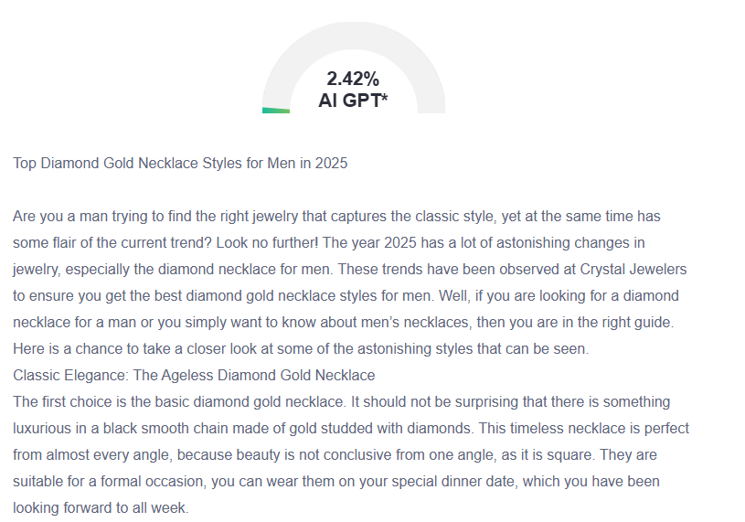

GMB
Crystal Jewelers in Greensboro welcomes customers to explore our 2025 collection of diamond and gold necklaces designed to embody the pinnacle of male sophistication. We offer classic chains with diamond enhancements together with sophisticated jewelry pieces featuring black diamonds, so men of all personal tastes can find something ideal. Layered necklaces are now the preferred accessory that empowers men to change between casual and formal occasions by offering diverse ways to showcase their personal style. The minimalist gentleman can choose delicate gold chains with understated diamond accents, which serve him for everyday wear. Enhance bold events by wearing our chunky diamond necklaces, which bring attention through their unique patterns along with masterful construction. The premier jewelry location in Greensboro allows Crystal Jewelers to help customers choose investment-worthy pieces that double as fashion accessories. Every necklace made from diamond gold in our assortment undergoes stringent quality tests for both authenticity and investment-level retention. The 2025 men's diamond necklace collection from our brand aligns modern design with everlasting elegance while providing an excellent choice for product selection and personal luxury purchases. Crystal Jewelers invites you to explore our collection for the necklace that will reflect your unique fashion identity precisely.

